SendGrid Configuration

Instructions

Table of Contents

Introduction 2

Create a SendGrid Account in Azure 2

Create an Account in SendGrid.com 6

Configure Email Templates on http://SendGrid.com 7

# Introduction

We use SendGrid to send emails (e.g. for registration confirmation, password resets, etc.) This document explains how to configure SendGrid.

# Create a SendGrid Account in Azure

1. Sign in to the Azure portal.
2. In the menu on the left, click **Create a resource**.

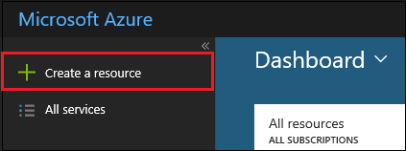

1. Click **Add-ons** and then **SendGrid Email Delivery**.

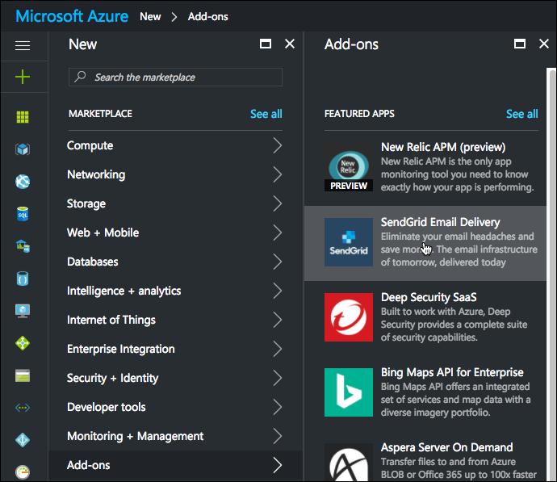

1. Complete the signup form and select **Create**.

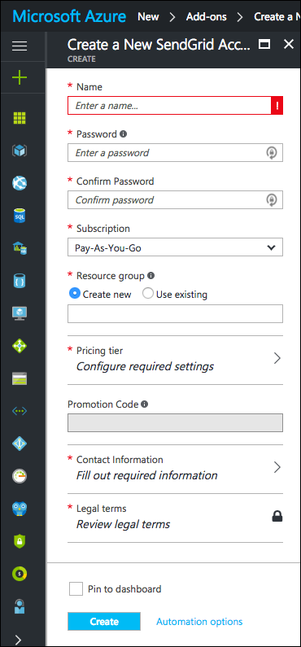

1. Enter a **Name** to identify your SendGrid service in your Azure settings.
2. Enter and confirm your **Password**.
3. Choose your **Subscription**.
4. Create a new **Resource group** or use an existing one.
5. In the **Pricing tier** section select the SendGrid plan you want to sign up for.
6. Press Create. Let your resource deploy: It may take up to a few minutes for Azure to provision your new SendGrid service. Wait a few minutes, or until the Azure portal says the operation is complete, and then open your resource group and refresh to see your new service.

**Important!!!**

We will need account details for SendGrid account in order to have opportunity add email templates, get apiKey for our app etc. (edited).

# Create an Account in SendGrid.com

1. You’ll also need an account on <http://SendGrid.com>
2. Go to the site and create one.

# Configure Email Templates on <http://SendGrid.com>

1. Go to <https://sendgrid.com/templates>
2. Inspect and configure your templates.